Share the Plate. Each month one-half of the loose currency in the offering plate is donated to a cause with a local presence which advances important principles of Unitarianism. This month’s recipient is Habitat for Humanity. We encourage you to learn more by visiting: https://habitatomaha.org.

Change for Change. Each week generous people put change in the collection plate. This change goes to our Sunday School youth who decide where the money can be best utilized. In the past they have contributed to Community Meals and International Bridges for Justice. This year youth have identified the recipient as Neighborhood Ministry Team, which purchases bus tickets, and food cards and provides blessings bags to people who come to our church requesting help. Your change makes a difference! Thank you for your generosity!

Rev. Frank Rivas, Minister (minister@firstuuomaha.org)
Rev. Ron Knapp, Minister Emeritus
Jan Wilson, Director of Religious Education (dre@firstuuomaha.org)
Carrie Helmberger, Membership Coordinator (coordinator@firstuuomaha.org)
Catharine Dixon, Church Administrator (admin@firstuuomaha.org)
Jenny Hastings, Nursery Coordinator
Patricia Will, Organist
William Miller, Choir Director
Elizabeth Kelly, Choir Accompanist
Stan Harper, Pianist
Robert Medrano, Custodian

3114 Harney Street

Omaha, Nebraska 68131
(402) 345-3039
www.firstuuomaha.org

First Unitarian Church of Omaha

Order of Worship

January 1, 2017

10:30 A.M.

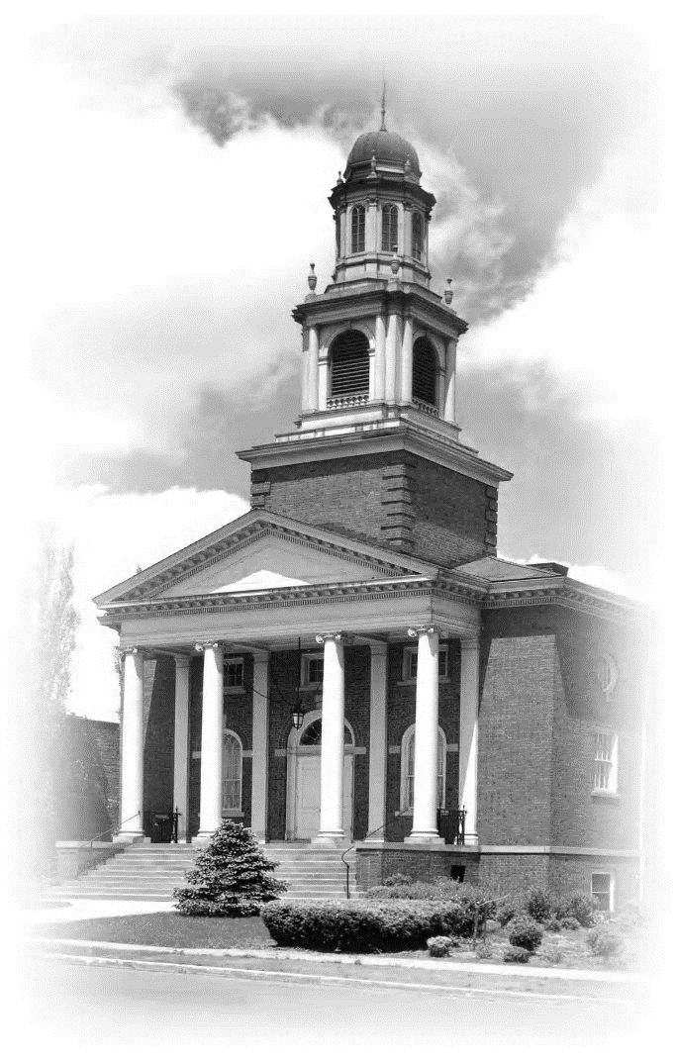

The First Unitarian Church of Omaha strives to be a welcoming, liberal religious community with traditions of reason and tolerance, which are reflected in how we live our lives. We are committed to introducing our youth to the breadth of religious thought and encouraging them to responsibly discern their own spiritual paths. We promote spiritual growth, social justice and sustainable living to affect positive change in our society and ourselves.

Order of Worship
January 1, 2017
10:30 A.M.
* OPENING HYMN (#346) “Come, Sing a Song with Me”
WELCOME
STORY FOR ALL AGES “The Wooden Knife” Rev. Shawna Foster
* CHALICE LIGHTING
In the mystery of life about us there is light.
It gives us a place to be, to grow, to rejoice together.
It opens the pathways to love.
In this place of friendship there is freedom.
Let the light we kindle go before us,
Strong in hope, wide in good will,
Inviting the day to come. — George Kimmich Beach
* SINGING THE CHILDREN TO THEIR CLASSES
Go now in peace. Go now in peace.
May the Spirit of Love surround you
Everywhere, everywhere you may go.
ANNOUNCEMENTS
OFFERTORY
The Share the Plate beneficiary for the month of January is Habitat for Humanity.
The Change for Change beneficiary is the Neighborhood Ministry Team.
(*Indicates congregation stands as they are able.)

SONG (remain seated) “When I breath in, I breath in peace.”
READING “Community Means Strength” — Starhawk
PASTORAL PRAYER AND MEDITATION
SERMON “Religious, but not Spiritual” Rev. Shawna Foster
* CLOSING HYMN (#123) “Spirit of Life”
* BENEDICTION
* DOXOLOGY

