Share the Plate. Each month one-half of the loose currency in the offering plate is donated to a cause with a local presence which advances important principles of Unitarianism. This month’s recipient is Black and Pink, an open family of LGBTQ prisoners and “free world” allies who support each other. Their work toward the abolition of the prison industrial complex is rooted in the experience of currently and formerly incarcerated people. This organization responds through advocacy, education, direct service, and organizing. Visit www.blackandpink.org for more information.
Change for Change. Each week generous people put change in the collection plate. This change goes to our Sunday School youth who decide where the money can be best utilized. In the past they have contributed to Community Meals and International Bridges for Justice. This year youth have identified the recipient as Neighborhood Ministry Team, which purchases bus tickets, and food cards and provides blessings bags to people who come to our church requesting help. Your change makes a difference! Thank you for your generosity!

Rev. Michelle LaGrave, Interim Minister (minister@firstuuomaha.org)
Rev. Dr. Sarah Voss, Affiliated Community Minister
Rev. Ron Knapp, Minister Emeritus
Rev. Frank Rivas, Minister Emeritus
Christina Strong, Life Span Director of Religious Education (dre@firstuuomaha.org)
Carrie Helmberger, Membership Coordinator (coordinator@firstuuomaha.org)
Catharine Dixon, Church Administrator (admin@firstuuomaha.org)
Patricia Will, Organist
William Miller, Sanctuary Singers Director
J Gawf, Sanctuary Singers Accompanist
Stan Harper, Early Morning Riser Director
Andrea Laudi, Nursery Coordinator
Robert Medrano, Custodian
3114 Harney Street

Omaha, Nebraska 68131
(402) 345-3039
www.firstuuomaha.org

First Unitarian Church of Omaha

Order of Service

February 23, 2020

10:30 A.M.

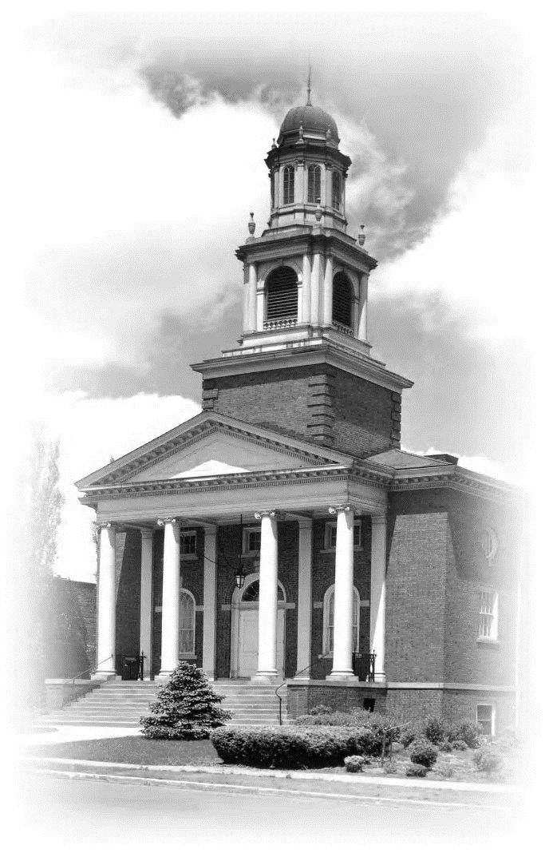

An inclusive community that listens, engages, inspires, and acts.

Order of Service
February 23, 2020
10:30 A.M.
BELLSOUND
PRELUDE “Three Little Birds” — Bob Marley
INTRODUCTION & ANNOUNCEMENTS Catherine Plumlee
WELCOME Rev. Michelle LaGrave
OPENING WORDS “The Great Teachers in Life” — Jason Cook
* OPENING HYMN (#187 gray hymnal) “It Sounds Along the Ages”
* CHALICE LIGHTING
At times our own light goes out and is rekindled by a spark from another person. Each of us has cause to think with deep gratitude of those who have lighted the flame within us. — Albert Schweitzer
STORY FOR ALL AGES “Starfish” — Loren Eiseley
SINGING THE CHILDREN OUT
Go now in peace. Go now in peace.
May the spirit of love surround you,
everywhere, everywhere you may go
RIGHT RELATIONS MINUTE Rev. Dr. Sarah Voss
MUSIC “The Fear” — Lily Allen
MEDITATION “The Web of Life” — Robert Weston

(*Indicates congregation stands as they are able.)

OFFERTORY AND OFFERING “Got to Begin Again” — Billy Joel
The Share the Plate beneficiary for the month of February is
Black & Pink
The Change for Change beneficiary is the Neighborhood Ministry Team.
READING “The Paradox of Tolerance” — Karl Popper
HYMN (#297 gray hymnal) “The Star of Truth”
SERMON “Wonder Woman, Fake News, Rev. Michelle LaGrave
Lie Detectors, & Reasons for Hope - Part I”
* CLOSING HYMN (#311 gray hymnal) “Let It Be a Dance”
CLOSING WORDS “Cherish Your Doubts” — Michael A. Schuler
* EXTINGUISHING THE CHALICE
BENEDICTION “Now May the Love of Truth” — Jame E. Mauldin
POSTLUDE

Thank you to Diane Withem for today’s flowers.

Early Morning Risers
EMR Director: Stan Harper

With deepest gratitude for all those who made today's service, religious education programming, and social hour possible.

Use the QR code to the right to see the news.

